ГУАП
КАФЕДРА № 43
ОТЧЕТ
ЗАЩИЩЕН С ОЦЕНКОЙ
ПРЕПОДАВАТЕЛЬ
ассистент |  |  |  | И. М. Лозоватский
должность, уч. степень, звание |  | подпись, дата |  | инициалы, фамилия

ОТЧЕТ О ЛАБОРАТОРНОЙ РАБОТЕ №4

Использование функционалов в языке LISP

по курсу: ФУНКЦИОНАЛЬНОЕ И ЛОГИЧЕСКОЕ ПРОГРАММИРОВАНИЕ
РАБОТУ ВЫПОЛНИЛ
СТУДЕНТ ГР. № | 4236 |  |  |  | Н. С. Борщ
 |  |  | подпись, дата |  | инициалы, фамилия

Санкт-Петербург 2024

- Задание
Цель работы - ознакомиться с применением функционалов в языке Lisp.
Указания. Используя связывание свойств с символами, структуры, последовательности и функционалы реализовать программу для предложенного ниже варианта, выполняющую:
- включение/исключение/замену данных;
- 4-5 поисковых запроса (разработать самостоятельно и согласовать с преподавателем).
Формальным требованием является использование последовательностей и функционалов при выполнении задания
- Листинг кода

(defstruct theatrical-plays
id
type-of-play
theater
currency
type-of-difference
cost
)

(setq map ( list
(make-theatrical-plays
:id '1
:type-of-play 'drama
:theater "Broadway"
:currency 'USD
:type-of-difference 'reverse
:cost 2500)
(make-theatrical-plays
:id '2
:type-of-play 'comedy
:theater 'WestEnd
:currency 'EUR
:type-of-difference 'straight
:cost 1000)
(make-theatrical-plays
:id '3
:type-of-play 'musical
:theater "Royal Opera House"
:currency 'USD
:type-of-difference 'reverse
:cost 3500)
)
)

(defun print-theatrical-plays (theatrical-plays)
(format t "ID: ~a~%" (theatrical-plays-id theatrical-plays))
(format t "Type of play: ~a~%" (theatrical-plays-type-of-play theatrical-plays))
(format t "Theater: ~a~%" (theatrical-plays-theater theatrical-plays))
(format t "Currency: ~a~%" (theatrical-plays-currency theatrical-plays))
(format t "Type of difference: ~a~%" (theatrical-plays-type-of-difference theatrical-plays))
(format t "Cost: ~a~%~%" (theatrical-plays-cost theatrical-plays))
)

(defun add-theatrical-plays (id typeplay theater currency typeofdif cost map)
(reverse (cons (make-theatrical-plays :id id
:type-of-play typeplay
:theater theater
:currency currency
:type-of-difference typeofdif
:cost cost)
(reverse map))
)
)

(defun delete-theatrical-plays (map &optional par)
(if (numberp par)
(if (car map)
(if (eq (theatrical-plays-id (car map)) par)
(remove (car map) map)
(cons (car map) (delete-theatrical-plays (cdr map) par))
)
map
)
(if (car map)
(if (eq (theatrical-plays-theater (car map)) par)
(cons (car map) (delete-theatrical-plays (remove (car map) map) par))
(cons (car map) (delete-theatrical-plays (cdr map) par))
)
map
)
)
)

(defun update-theatrical-plays (map id typeplay theater currency typeofdif cost)
(if (car map)
(if (eq (theatrical-plays-id (car map)) id)
(setf (car map)
(make-theatrical-plays :id id
:type-of-play typeplay
:theater theater
:currency currency
:type-of-difference typeofdif
:cost cost)
)
(update-theatrical-plays (cdr map) id typeplay theater currency typeofdif cost)
)
)
)

(defun search-func (map f par &optional(f2 'eq) l)
(if (car map)
(if (funcall f2 (funcall f (car map)) par)
(search-func (cdr map) f par f2 (print-theatrical-plays (car map)))
(search-func (cdr map) f par f2)
)
)
)

(print "Begin")
(print map)
(terpri)

(print "Test Adding")
(print (setq map (add-theatrical-plays 4 'tragedy 'WestEnd 'RUB 'reverse 4000 map)))
(terpri)

(print "Test Updating")
(update-theatrical-plays map 4 'tragedy 'WestEnd 'RUB 'straight 4000)
(print map)
(terpri)

(print "Test Deleting")
(print (delete-theatrical-plays map 3))
(terpri)

(print "All Data")
(terpri)
(mapcar 'print-theatrical-plays map)

(print "Finding for type of play (comedy)")
(terpri)
(search-func map 'theatrical-plays-type-of-play 'comedy)

(print "Finding for cost (4000)")
(terpri)
(search-func map 'theatrical-plays-cost 4000)

(print "Finding for cost (<3000)")
(terpri)
(search-func map 'theatrical-plays-cost 3000 '<)

(print "Finding for id (2)")
(terpri)
(search-func map 'theatrical-plays-id 2)

(print "Finding for currency (USD)")
(terpri)
(search-func map 'theatrical-plays-currency 'USD)

(print "Finding for type of difference (reverse)")
(terpri)
(search-func map 'theatrical-plays-type-of-difference 'reverse)

- Результат работы программы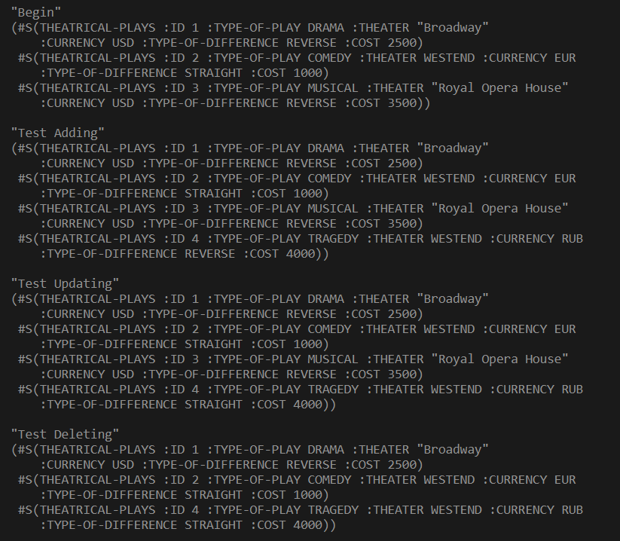 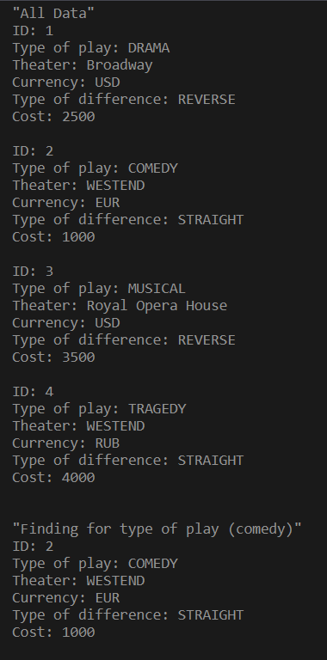
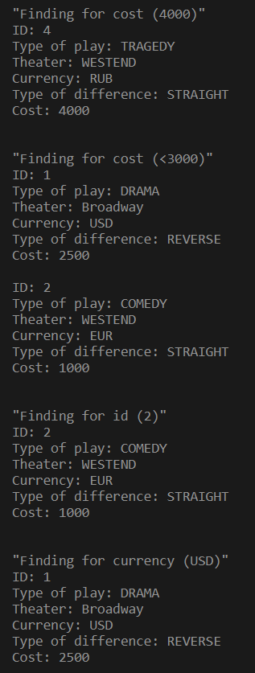
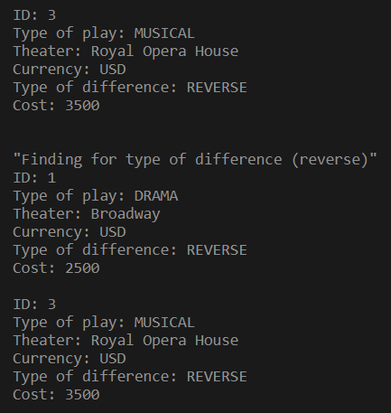

- Вывод

В ходе данной лабораторной работы я ознакомился с применением функционалов в языке Lisp.

